**DAILY ONLINE ACTIVITIES SUMMARY**

|  |  |  |  |  |  |  |  |  |
| --- | --- | --- | --- | --- | --- | --- | --- | --- |
| **Date:** | **04-06-2020** | | | | | **Name:** | **Shetty Disha Ravindra** | |
| **Sem & Sec** | **VI B sec** | | | | | **USN:** | **4a17cs087** | |
| **Online Test Summary** | | | | | | | | |
| **Subject** | | Operating Systems | | | | | | |
| **Max. Marks** | | 30 | | **Score** | | | 13 | |
| **Certification Course Summary** | | | | | | | | |
| **Course** | Data Structures and Algorithms in Java | | | | | | | |
| **Certificate Provider** | | | **-** | | **Duration** | | | 1.5hrs |
| **Coding Challenges** | | | | | | | | |
| **Problem Statement:1]**  Python program to combine the strings | | | | | | | | |
| **Status:executed** | | | | | | | | |
| **Uploaded the report in Github** | | | | | **Yes** | | | |
| **If yes Repository name** | | | | | **Disha_Shetty** | | | |
| **Uploaded the report in slack** | | | | | **Yes** | | | |
| **PYTHON ASSIGNMENT PROGRAM**  **1]** **Python Program to Accept a Hyphen Separated Sequence of Words as Input and Print the Words in a Hyphen-Separated Sequence after Sorting them Alphabetically**  Screenshot (91).png  Couldn’t achieve the desired output….The string is displayed more than once somehow | | | | | | | | | |

Online Test Details: (Attach the snapshot and briefly write the report for the same)

Certification Course Details: (Attach the snapshot and briefly write the report for the same)

Coding Challenges Details: (Attach the snapshot and briefly write the report for the same)

Online test

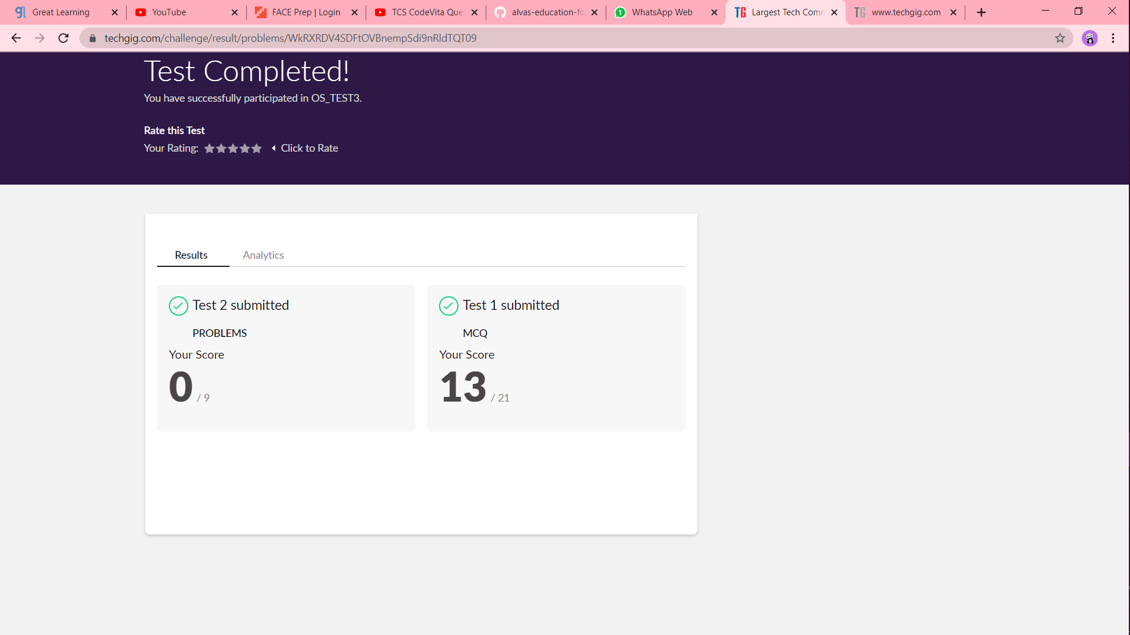

Certification progress

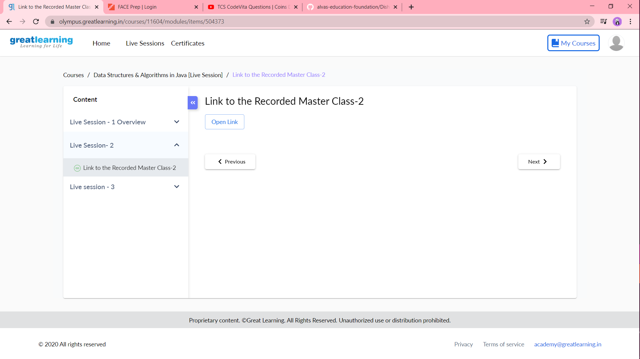

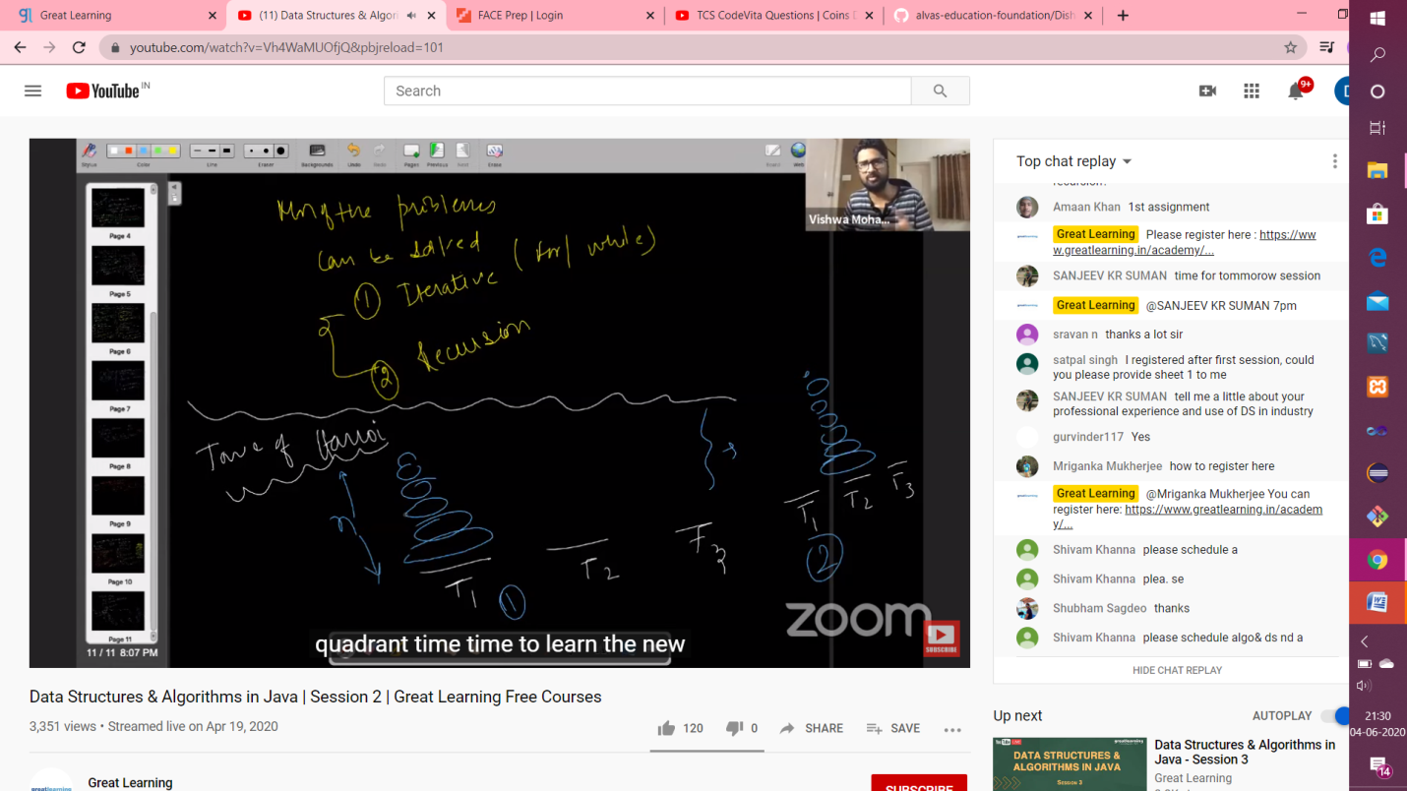

Coding challenge output

1]

